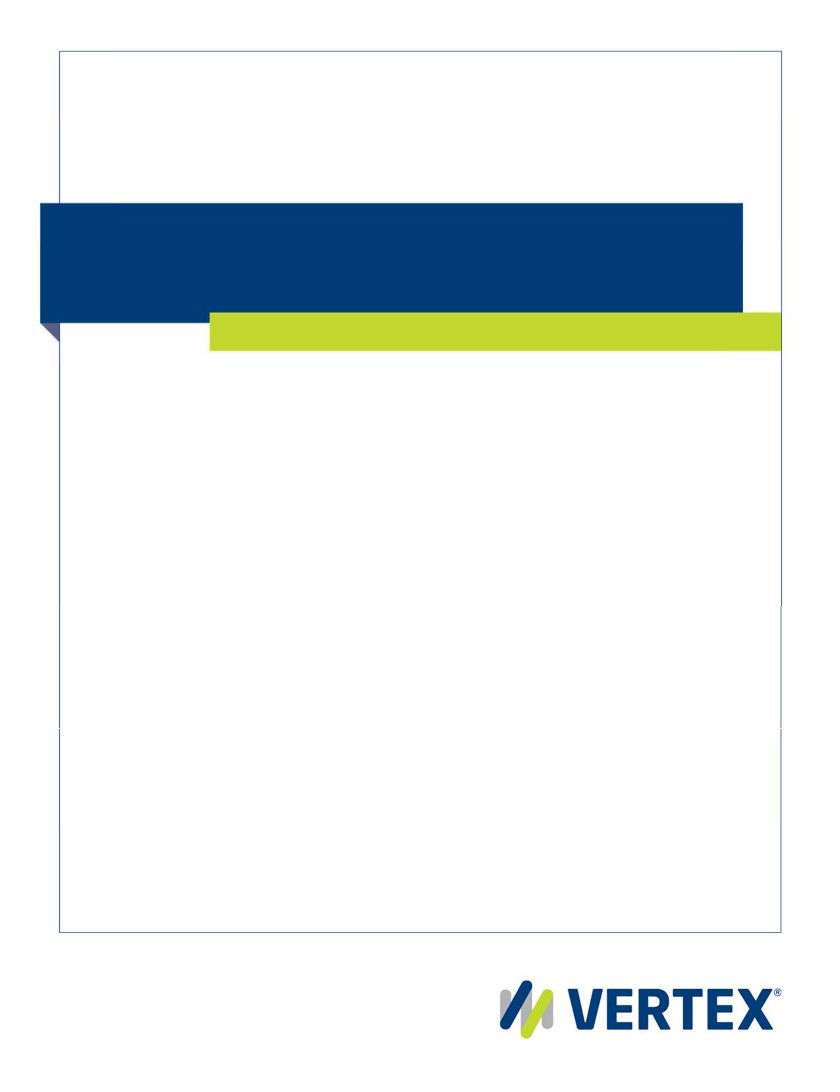
Vertex® Tax Links for Salesforce Commerce Cloud Implementation guide

Copyright and legal notices

Copyright © 2020 Vertex Global Tax Solutions Ireland Holdings. All rights reserved.

This documentation may not be reproduced, displayed, distributed, modified, posted, republished, or transmitted in any form or by any means, without the prior written consent of Vertex Global Tax Solutions Ireland Holdings or its affiliates (collectively, “Vertex”), except as otherwise specified in a valid, current Vertex license agreement or allowed by law.

Disclaimers

The information contained in this documentation is designed to help users in regard to the subject matter covered. Some of it may be based upon interpretations of federal, state, foreign and other tax laws and regulations. Each entity is responsible for making its own determination of how such laws and regulations apply to its own circumstances and for evaluating the capabilities of, and all data and results generated by, any product that is described in this documentation. Vertex is not engaged in providing legal, tax or accounting advice or services and the information contained in this documentation or in any product cannot replace the advice of competent legal counsel. Further, the information in this documentation is subject to change without notice and is not warranted to be error‐free. If you find any errors, please report them to us in writing.

Trademarks and Service Marks

The trademarks, logos and service marks ("marks") displayed in this documentation are the property of Vertex or other third parties. Users are not permitted to use these marks without the prior written consent of Vertex or the third party that may own the mark.

Third Party Products

Copies of the licenses for some third‐party products included with a Vertex product may be found in or with the installation materials for that product.

Contents

Contents 3
Preface 4
About Vertex and our services 4
Contacting Vertex 4
About Vertex® Tax Links 5
About this guide 5
Chapter 1. Setup 6
Compatibility 6
Connector File set 6
Chapter 2. Installation 8
Installation of the Connector cartridge in Salesforce Commerce Cloud 8
Import Metadata, Jobs & Services 15
Assigning cartridges 17
Configuring your site 17
Configuring the Business Manager site 19
Upgrading from previous versions 20
Chapter 3. Appendix 24
Accessing and troubleshooting Log Files 24
Request Detailed Log 27
Delete Request Endpoint 27
Multishipping implementation 30
Messaging Examples and Data Mapping 30
Sample XML Request Message 30
Sample XML Response Message 31
Request data Mapping 32
Response data Mapping 33
Release History 33

Preface

This preface contains the following information:

- About Vertex® and how to contact us about technical questions
- About Vertex® Tax Links
- About this guide

About Vertex and our services

Vertex Inc. is the leading provider of corporate tax software and services for companies of all sizes, from small to medium‐sized businesses to global multinationals. Vertex provides solutions in every major line of tax including income, sales and consumer use, value added, and payroll. Vertex also offers tailored solutions for specific industries including retail, communications, hospitality, and leasing.

Vertex has offices in Berwyn, Pennsylvania; Sarasota, Florida; Naperville, Illinois; London, United Kingdom; and São Paulo, Brazil. For office addresses and telephone numbers, go to

Contacting Vertex

Vertex provides the following services:

D
For... | Go to...
Technical questions about your products | Vertex Product Support  Phone: 800.281.1900 (Monday through Friday, 8:15 A.M. to 8:00 P.M. United States Eastern Time)  Web: https://my.vertexinc.com/
Documentation, downloads, forums, service requests, and up‐to‐ the‐minute information about tax rates, tax rules, and jurisdictions | The myVertex customer portal  Web: https://my.vertexinc.com/
Questions about your licensing agreement, license renewal, invoicing arrangements, or obtaining license files for your products | Vertex Account Services  Phone: 800.355.3500 or 610.640.4200  Web:
Regional training classes, web‐based training classes, or on‐ site training at your facility | Vertex Training  Phone: 877.455.2645 (Monday through Friday, 8:15 A.M. to 8:00 P.M. United States Eastern Time) option #2  Web:

About Vertex® Tax Links

Vertex® Tax Links for Salesforce Commerce Cloud provides integration with Vertex® O Series® XML Service for tax calculation and address verification.

About this guide

The Setup Guide provides the following information:
- Instructions for installing the Salesforce Commerce Cloud connector
- Instructions on how to access and view Log Files to assist with Troubleshooting

Chapter 1. Setup

Compatibility

The cartridge is designed for Salesforce Commerce Cloud API version 19.10 (Compatibility Mode: 19.10) with SFRA version 4.4.1.
In case the service is down, the storefront continues to work without the service. All errors work of the service are saved in the log file.

Connector File set

The following components are included in the Connector file set.

Cartridge name | int_vertex
Scripts | /scripts  constants.js  vertex.js  /helper  deleteRequest.js  helper.js  /init  initVertexApi.js  /lib  generalLogger.js  libVertexApi.js
Templates | /templates/default/checkout/vertex  multishippingsuggestions.isml  suggestions.isml
Resources | /templates/resources  vertex.properties
Webreferences2 | /webreferences2  CalculateTax.wsdl  LookupTaxAreas.wsdl  VertexInc-AccrualSync.xsd  VertexInc-Accrual.xsd  VertexInc-APInvoiceSync.xsd  VertexInc-ARBillingSync.xsd  VertexInc-AssetMovement.xsd  VertexInc-BuyerInputTax.xsd  VertexInc-ChangedTaxAreaRequest.xsd  VertexInc-ChangedTaxAreaResponse.xsd  VertexInc-CodeList-DeliveryTerm.xsd  VertexInc-CodeList-JurisdictionLevel.xsd  VertexInc-CodeList-TaxingLocation.xsd  VertexInc-CodeList-TaxingType.xsd  VertexInc-Common.xsd  VertexInc-Core.xsd  VertexInc-Delete.xsd  VertexInc-DistributeTaxProcurement.xsd  VertexInc-DistributeTax.xsd  VertexInc_Envelope.xsd  VertexInc-ERS.xsd  VertexInc-Exists.xsd  VertexInc-FindChangedTaxAreaRequest.xsd  VertexInc-FindChangedTaxAreaResponse.xsd  VertexInc-FindTaxAreasRequest.xsd  VertexInc-FindTaxAreasResponse.xsd  VertexInc-InventoryRemoval.xsd  VertexInc-InvoiceVerification.xsd  VertexInc-Invoice.xsd  VertexInc-PurchaseOrder.xsd  VertexInc-Quotation.xsd  VertexInc-Reversal.xsd  VertexInc-Rollback.xsd  VertexInc-TaxAreaRequest.xsd  VertexInc-TaxAreaResponse.xsd  VertexInc-Version.xsd
Cartridge name | bm_vertex
Controllers | VertexInc.js
Scripts | /cartridge/scripts  constants.js  libVertex.ds
Static | /cartridge/static/default  /css  style.css  /icons  logo.png  /js  handler.js
Templates | index.isml
Resources | vertex.properties
Cartridge name | int_vertex_controllers
Controllers | VertexEndpoint.js
Metadata | vertex.zip

Chapter 2. Installation

Installation of the Connector cartridge in Salesforce Commerce Cloud

Use the following steps to install the Connector cartridge in your instance of Salesforce Commerce Cloud.

- Open Salesforce Commerce Cloud Studio
- Using Eclipse Web Tools Platform as it is the official development environment for Salesforce Commerce Cloud.
- Save the Connector and associated files provided by Vertex locally
- Upload the Connector to the the Salesforce Commerce Cloud Sandbox environment
  - Open Eclipse
  - Import connector files labeled int_vertex and bm_vertex
    - Open Eclipse
    - Create a New Digital Server Connection
      - Click on File->New->Digital Server Connection
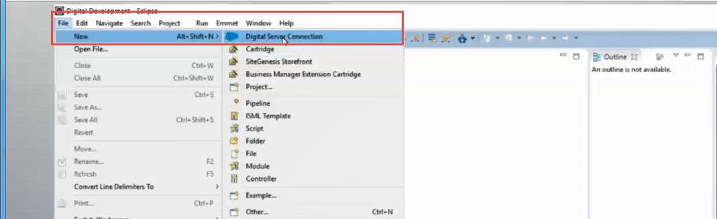
      - Enter Project Name as Vertex
      - Enter Host name (Your Salesforce Commerce Cloud Instance URL) and click Next
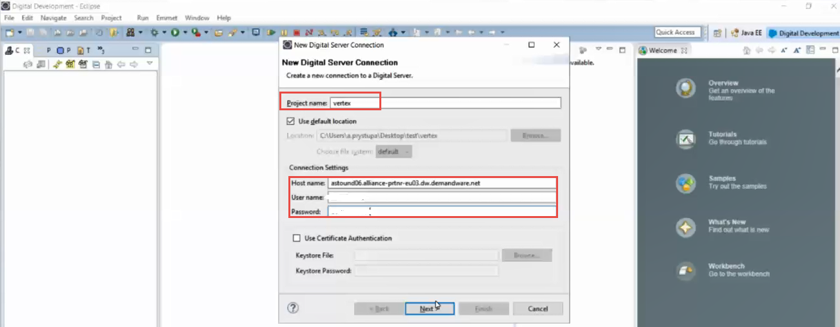
    - Select Target upload staging version directory
      - Select Vertexinc from drop down and click finish
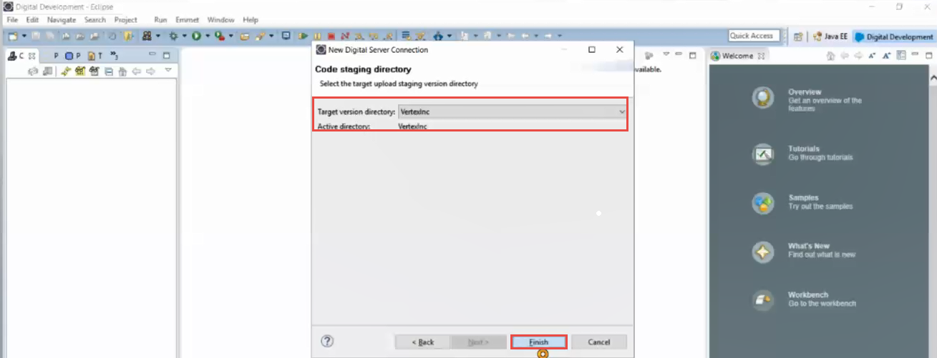
    - After build is complete import Existing Project into Workspace
      - File->Import->General->Existing Projects into Workspace
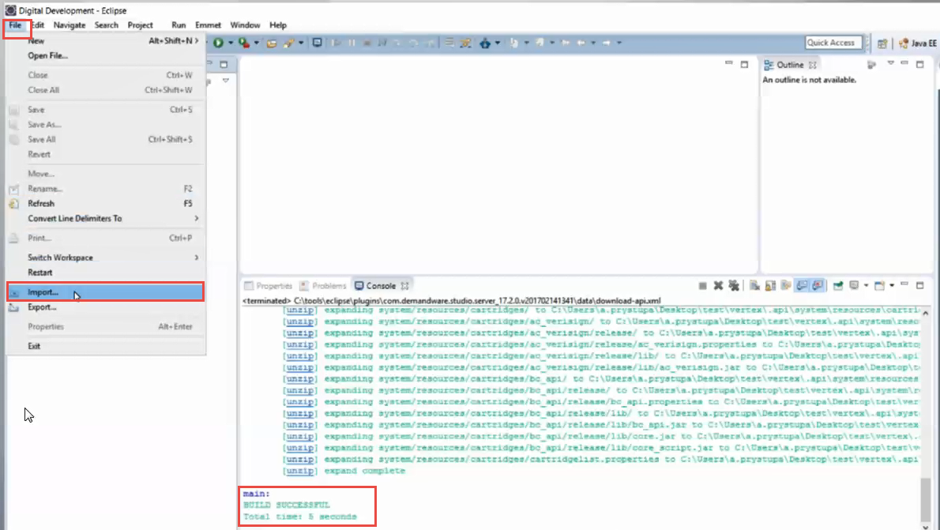
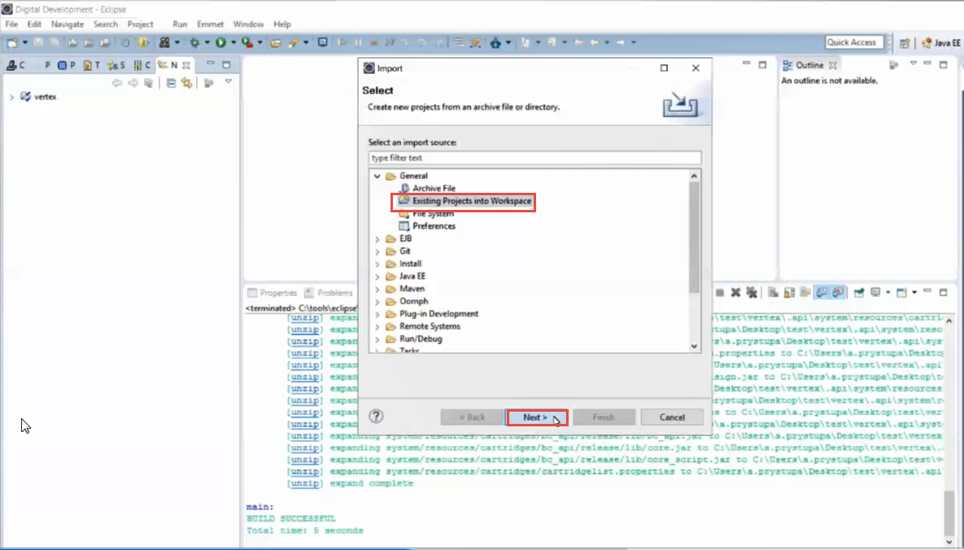
    - Import bm_vertex, int_vertex and int_sfra_vertex files from local drive
      - Click Browse from root directory
      - Select folder location where you saved Vertex Connector Zip File and click OK
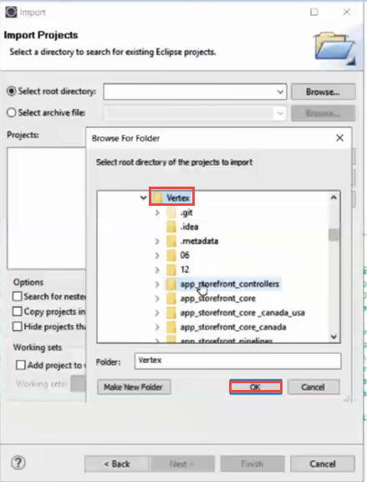
      - Select bm_vertex, int_vertex, int_vertex_controllers and int_vertex_sfra folders and click Finish
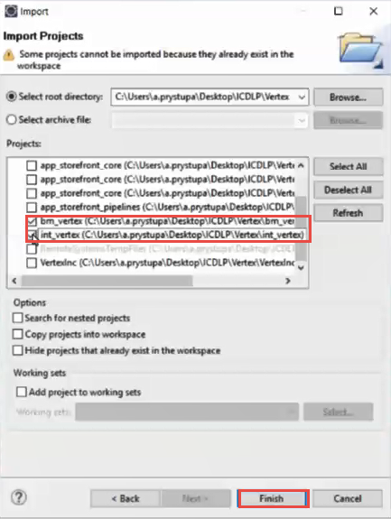

      - You will be presented with a message “? Do you want to attach the cartridges to a Digital Server?” Click Yes button
      - Check boxes next to bm_vertex, int_vertex and int_vertex_controllers, int_vertex_sfra and click OK
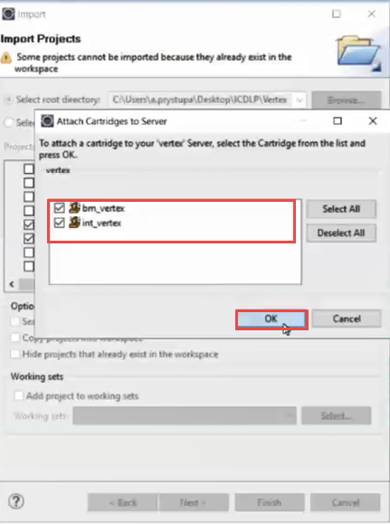
      - You will be presented with a Delete Server Cartridge message/window-> Make sure you leave all boxes UNCHECKED and click OK
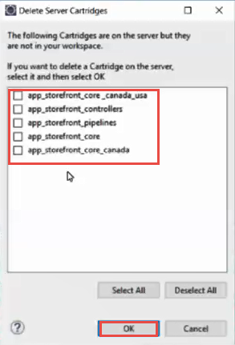

- Connector(s)are now uploaded to Salesforce Commerce Cloud Sandbox environment
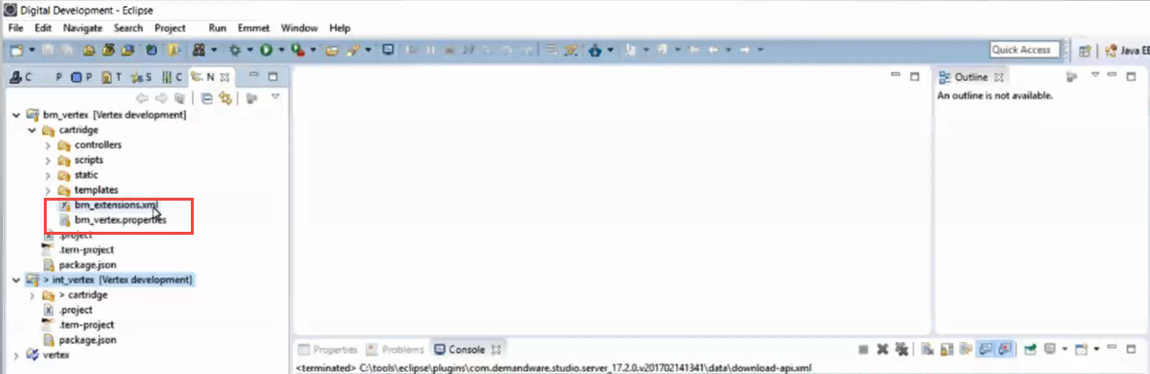
- To Validate, log into your Salesforce Commerce Cloud Instance
    - Go to Administration->Site Development->Code Deployment and click on the Vertex link
    - You will see a section labelled Cartridges with int_vertex, int_vertex_controllers, int_vertex_sfra and bm_vertex files listed
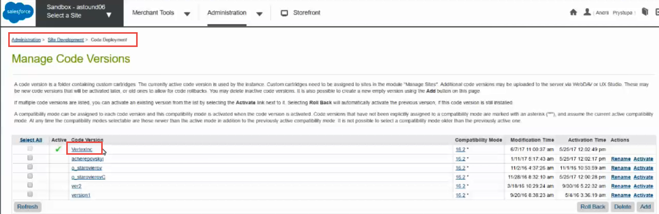
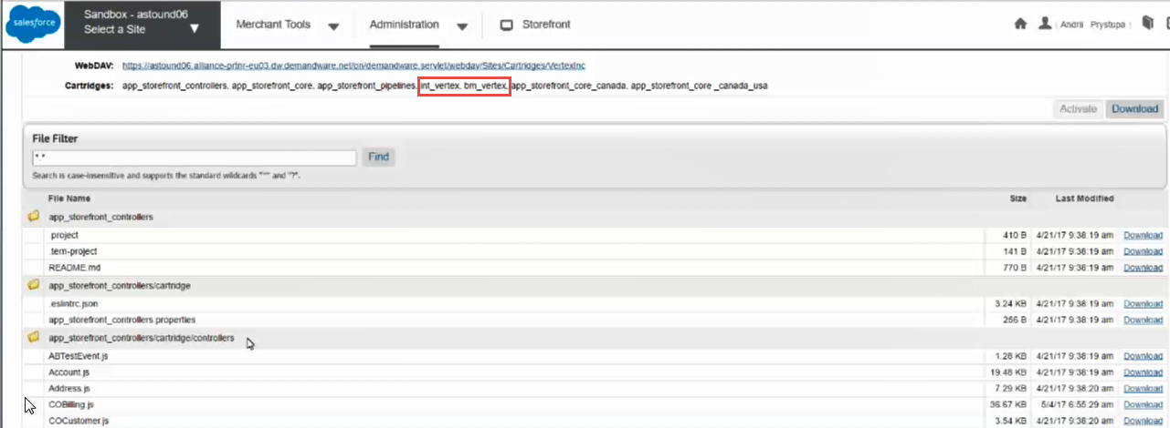

Import Metadata, Jobs & Services
Import the following vertex.zip Metadata. This will:
  - enable the health test job to ensure the connection from the Connector to Vertex is working correctly
  - imports required fields, physical regions and valued credential that must be imported into the Salesforce Commerce Cloud Connector
  - enable the SOAP Requests and Responses that need to be passed between the Connector and Vertex to allow for the Tax Area Look up/Address cleansing call to be made and accurate Tax Calculation.

- Click on Administration tab and then Site Development
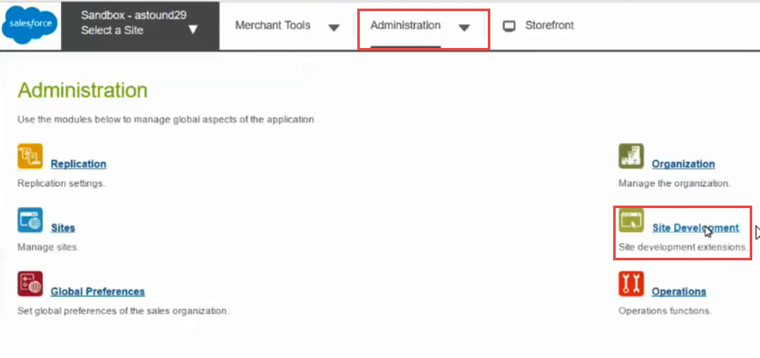
- Click on Site Import & Export link on Site Development page
- Upload vertex.zip files to the Sandbox instance
- Click Choose file button in Import section of Site Import & Export page and select vertex.zip from metadata folder
- Click on Upload button on right side of choosing file filed
- Select uploaded file in Import Section
- Click Import button
- Click OK on import confirmation message
- Wait until file will be successfully imported
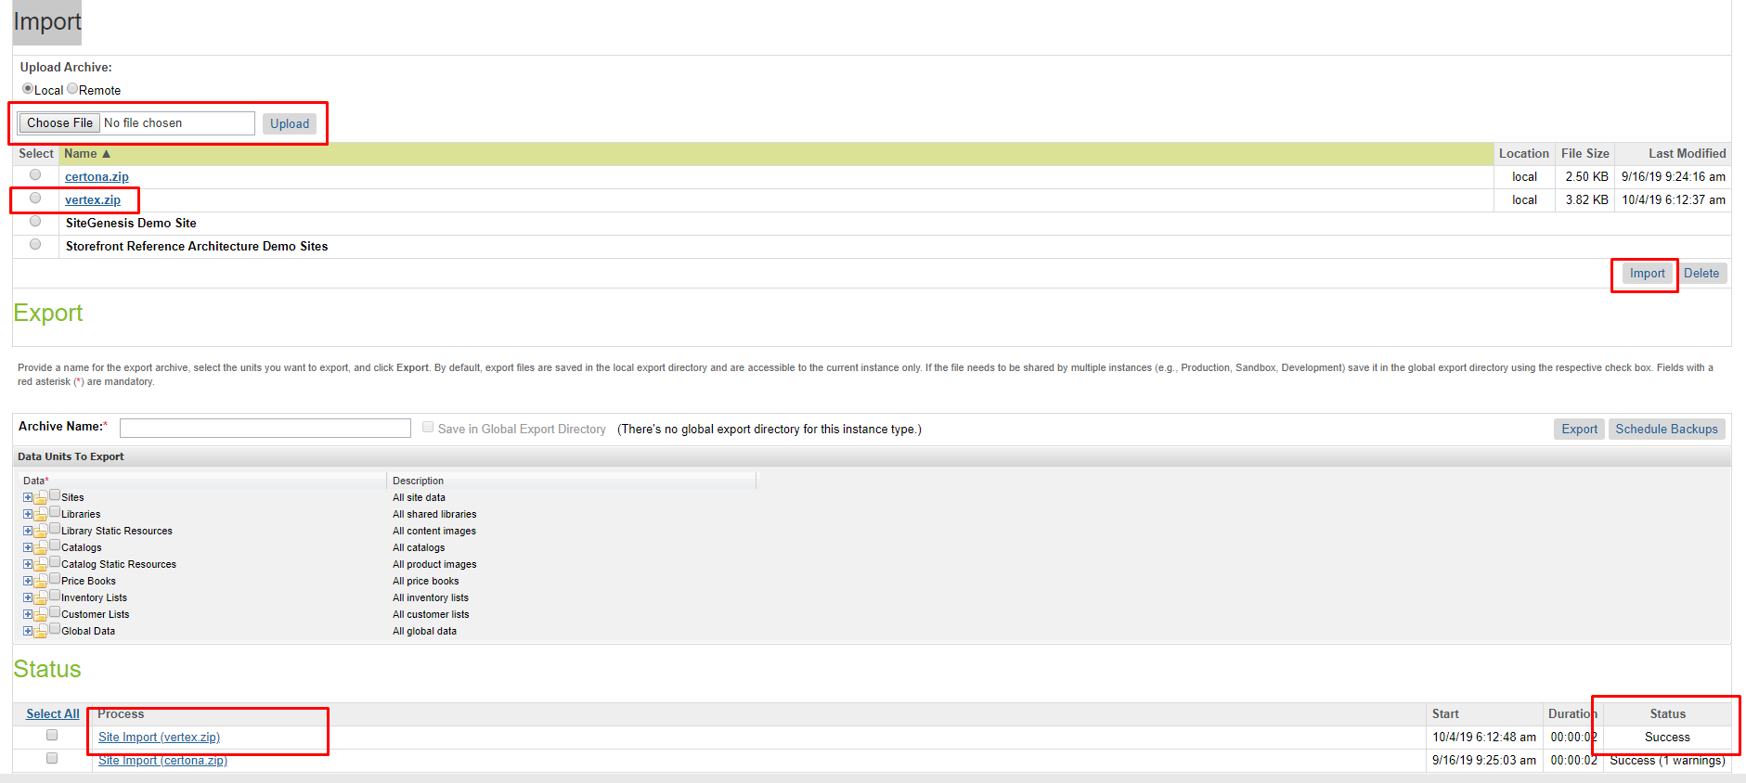

Assigning cartridges
Now that the Cartridges have been imported to Salesforce Commerce Cloud you will need to add them to the specific instance and to Business Manager (Storefront) within Salesforce B2C

Configuring your site
- Click on Administration at the top Navigation
- Click on Sites link
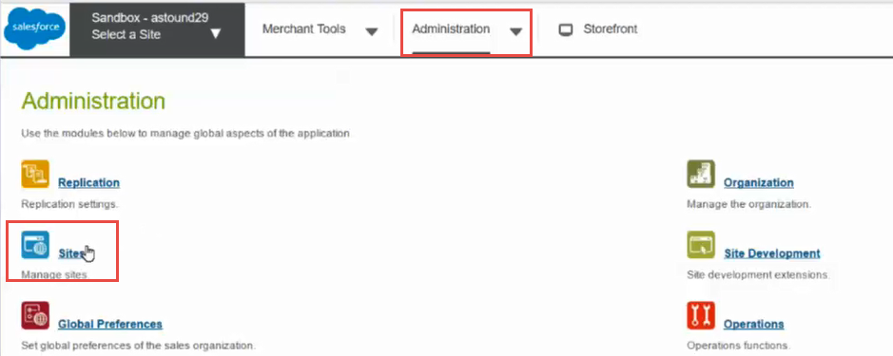
- Click on Manage Sites link
- Click on the site name you want to add the connector to
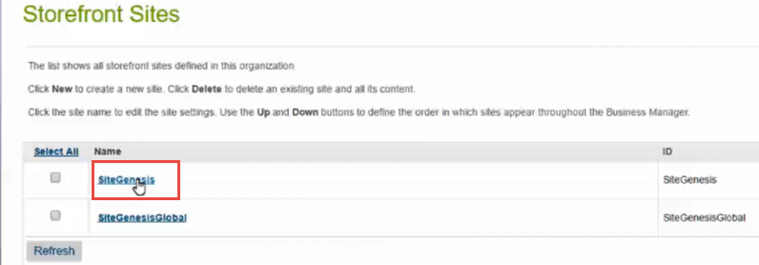
- Click on Settings Tab on Site Page
- In the field labeled Cartridges add required cartridges to the cartridge path: app_storefront_controllers:app_storefront_core:int_vertex:int_vertex_controllers or int_vertex:int_vertex_sfra:app_storefront_base if you are using SFRA version
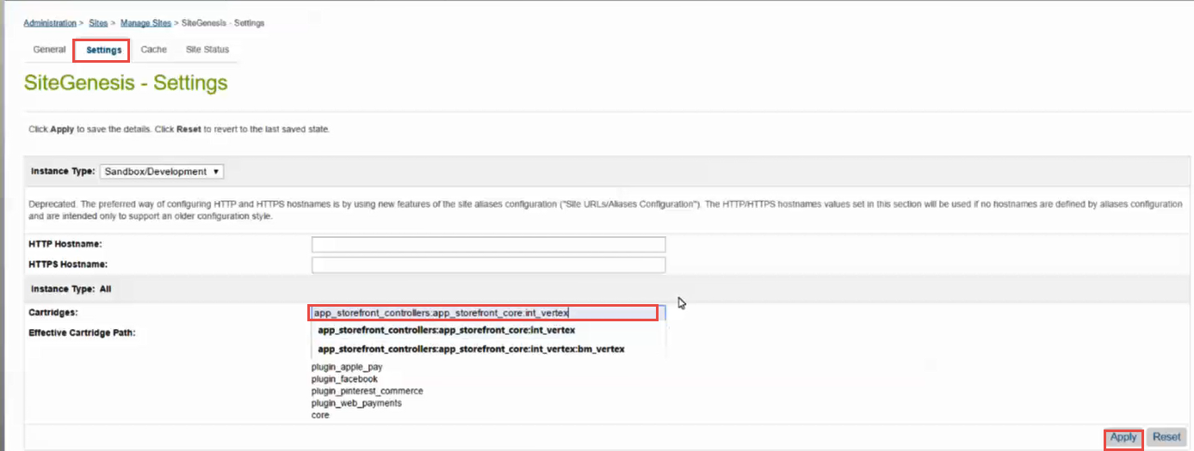

- Click Apply

Configuring the Business Manager site
- Click Back to list button
- Click on the Business Manager site link
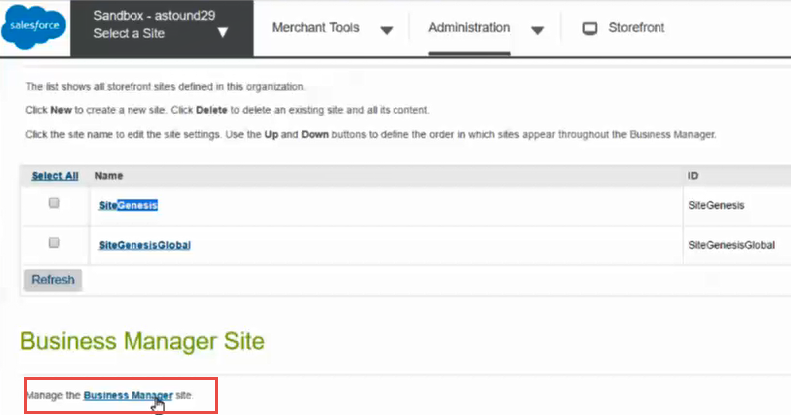
- Add int_vertex and bm_vertex to the field labeled Cartridges and click Apply
- After the page refreshes click Back to List button
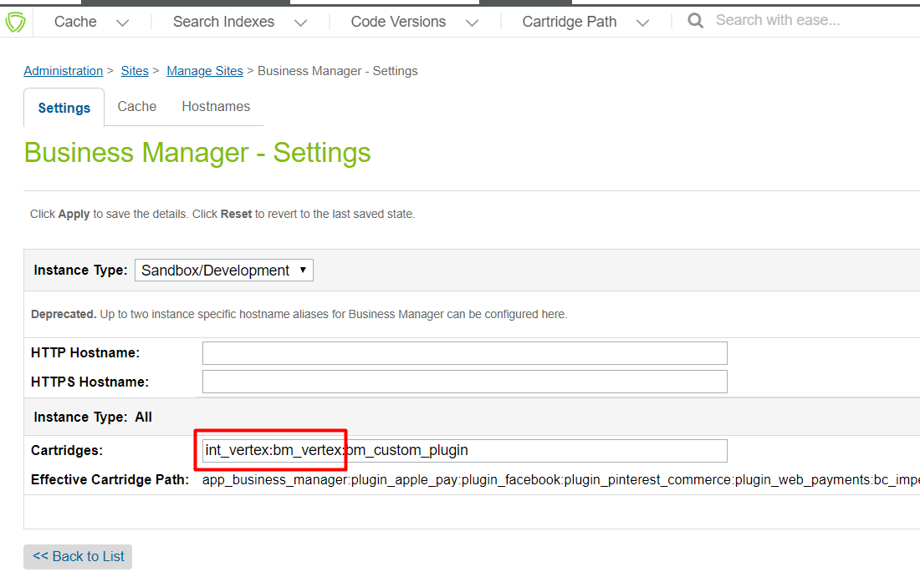

Upgrading from previous versions

If you are upgrading from a previous version of the Vertex Link cartridge please follow the below steps:
- Make sure that you already have a configured development environment as described in Chapter 2
- Replace the old integration cartridge files with new ones
- Refresh your project workspace when your current server connection is selected.
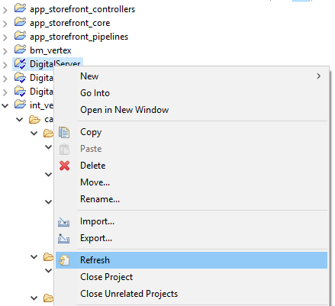

- Files should be uploaded automatically but it can be done manually in the context menu “Digital Server” -> “Upload Cartridges”
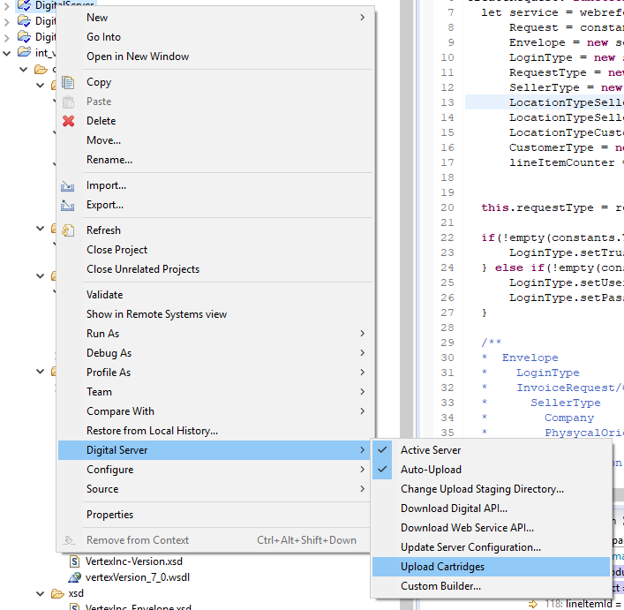

- After the cartridges are uploaded you will see upload result screen
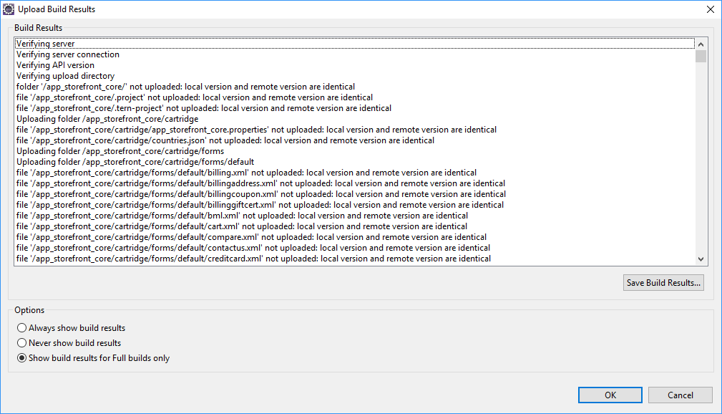
- You need to import metadata, services and jobs as described in Chapter 2
- Switch between code versions for clearing site and service cache. Enable the code version that is different from your current version and then switch back.

Chapter 3. Appendix

Accessing and troubleshooting Log Files
  - Accessing log files are important for troubleshooting when there are possible issues that need investigation. You will be able to see the information that is being passed to Vertex from the Connector as well as information being passed back from Vertex.
  - Log files are located in Administration -> Site Development -> Development Setup → Log Files

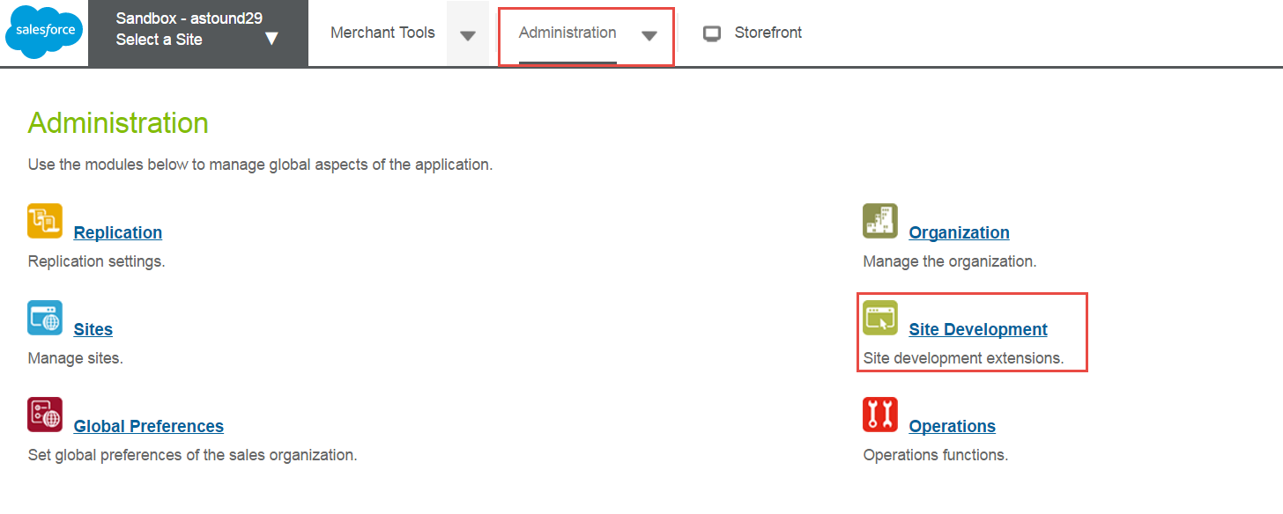
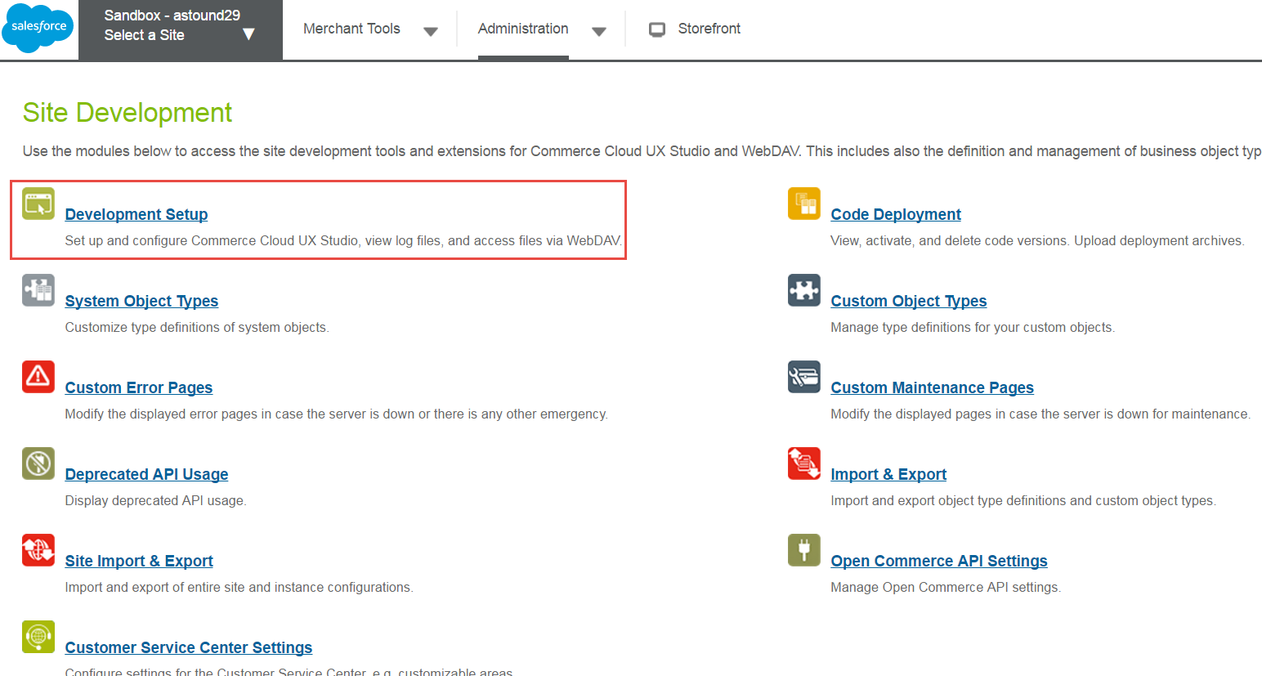

  - After Clicking on the log file link you will be asked to log into the Connector instance again with the same user name and password

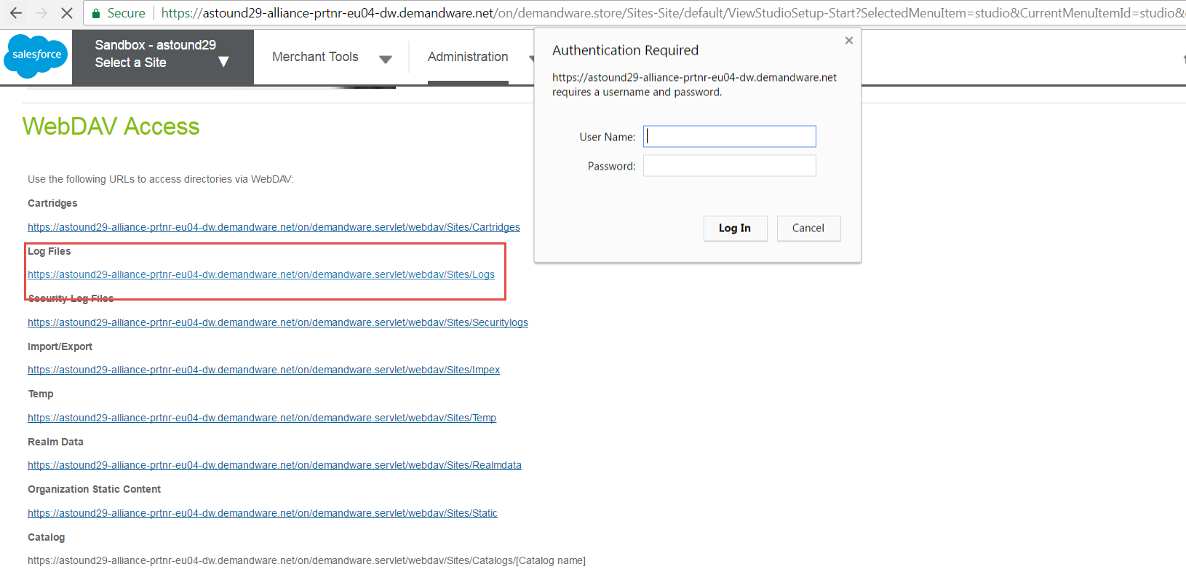

Vertex service logs are located in 3 files:

- custom-VertexInc-<instance_name>-appserver-<current_date>.log
- service-VertexSOAP-<instance_name>-appserver-<current_date>.log
- custominfo-<instance_name>-appserver-<current_date>.log
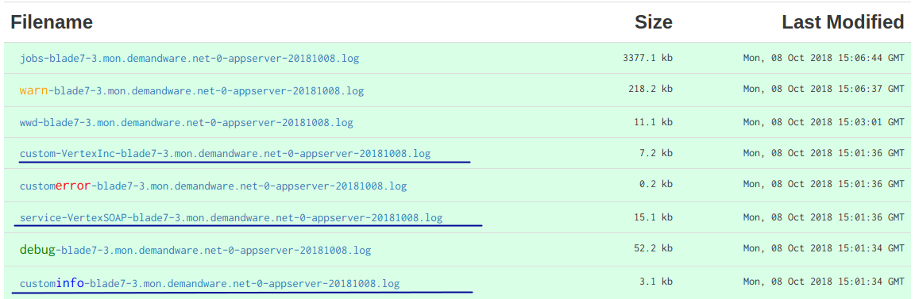
Depending on the file you will see different types of information.
custom-VertexInc-<instance_name>-appserver-<current_date>.log
All the log information being generated from the Vertex Cartridge code is written to this file. You can set the desired level of the log records (described in the connector documentation) in the custom preferences located at Merchant Tools > Site Preferences > Custom Site Preference Groups > Vertex

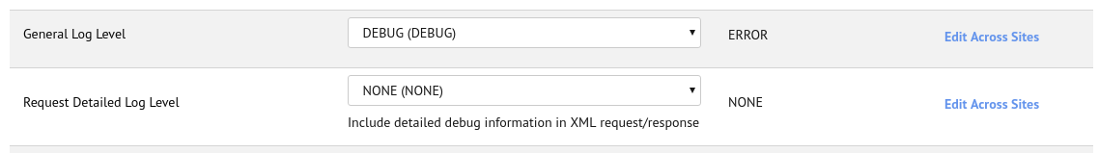

service-VertexSOAP-<instance_name>-appserver-<current_date>.log
This is the communication log file that holds all the request and response information in json format that was sent to and received from the Vertex Platform. Note that communication logs should be enabled in the Service settings. The Trusted Id and Login/Password are substituted with ‘*hidden*’ string.

custominfo-<instance_name>-appserver-<current_date>.log
Holds all the request and response information that was sent to and received from the Vertex Platform in XML. Warning: this file contains sensitive information in open form, and this log cannot be disabled on dev and staging instances. On production instances it is disabled by default.

  - Click on the log file you would like to access
  - Find the call (Tax Area Look up, Quotation Request or Responses)

Quotation Request example:
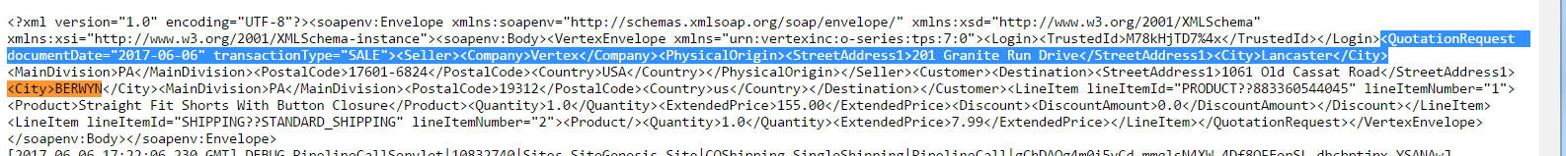

Quotation Response Example:
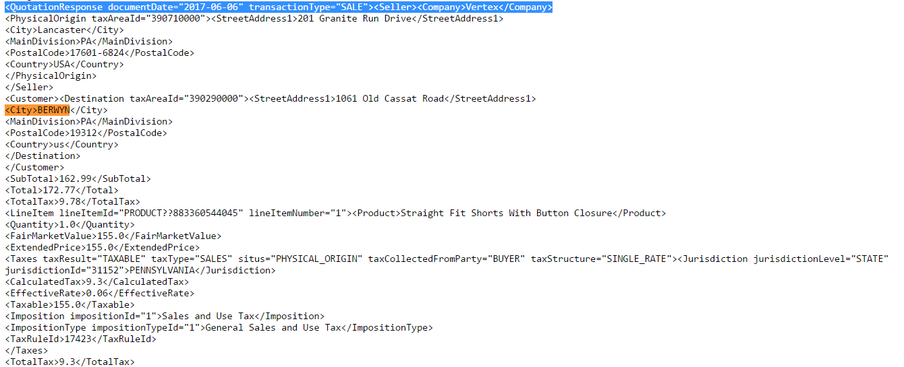

Request Detailed Log

At times, more detailed debug information is needed from the Vertex Platform for troubleshooting purposes. In order to tell the Vertex platform to include the detailed logging of the request processing in the XML Response, the Request Detailed Log Level option in the custom preferences is used.

Go to Merchant Tools > Site Preferences > Custom Site Preference Groups > Vertex

Set the Request Detailed Log Level parameter according to your needs:

NONE | No logs
FATAL | Logs any system condition or event that jeopardizes system integrity, such as allocation failures, disk space errors, or major database problems.
ERROR | Logs all abnormal events that are neither warnings nor fatal. Use this setting in a production environment.
WARNING | Logs any system condition or event that is abnormal but poses no risk to stability, performance, or answer quality.
OPS | Logs major system events, such as starting up or shutting down of major system components or services.
TRACE | Logs entry and exit points of substantial classes and services.
DEBUG | Logs a detailed description of software execution. Use this setting only if you are working in a development environment.
SUPPORT | Logs pertinent details to enhance Vertex Product Support troubleshooting.

Delete Request Endpoint

In order to allow the trusted clients to initiate the process of deleting transactions from Vertex O Series platform, the SFCC cartridge provides the public Controller-endpoint: "VertexEndpoint-DeleteRequest".

Sample url:

The request should be authorized and signed by the remote system with HMAC calculated with Remote Request Token. On your instance you should set the Remote Request Token value under the Merchant Tools > Site Preferences > Custom Site Preference Groups > Vertex, and provide it to the remote system developers.
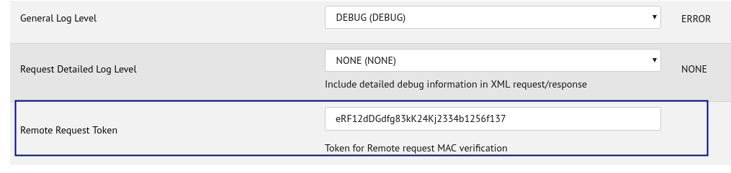
To initiate the delete request the remote system should send a http request to that url with the following parameters:

Request type: | POST
Protocol: | https
Additional headers: | x-vertex-hmac | A verification hash for the request. Generated by performing an SHA256 encryption on the request body string and subsequently calculating the HMAC hash of the result using the Remote Request Token.  All requests to the DeleteRequest endpoint must include this header.
Request body: | A result of JSON.stringify() of the following object:  {  requestType: "delete",  transaction: @string - the id of transaction to delete  source: @string - Name or any string to identify the the caller  } | Sample request body:  {  "requestType":"delete,  "transaction":"00001203",  "source":"Shipping department"  }

Command line samples:

First save the request in json format to the file body.json, then

1) Create a message digest:
$ openssl dgst -sha256 -hmac {RemoteRequestToken} < body.json
note the digest (after the ‘=’ sign)
$ (stdin)= 582e417bc125806ccae8885502252885b57128ff8bcd361379976aa948c5eb2f

2) Send a request:
$ curl -X POST \
https://yoursandbox-dw.demandware.net/on/demandware.store/Sites-vertexvat-Site/en_US/VertexEndpoint-DeleteRequest \
--data-binary @body.json \
-H "Content-Type: application/json" \
-H "x-vertex-hmac:{digest}"

x-vertex-hmac calculation sample:

function calculateHmac(data, stringKey) {
var bytesKey,
macSha256,
signature,
signatureBytes;

var Mac = require('dw/crypto/Mac');
var Encoding = require('dw/crypto/Encoding');
var Bytes = require('dw/util/Bytes');

macSha256 = new Mac(Mac.HMAC_SHA_256);
bytesKey = new Bytes(stringKey);

signatureBytes = macSha256.digest(data, bytesKey);
signature = Encoding.toHex(signatureBytes);

return signature;
}

Response codes:

The endpoint returns standard http response codes:

Code | Explanation
200 | Ok, request was sent to the Vertex platform
401 | Unauthorized. This appears if either the x-vertex-hmac header is missing or the hash provided with the request is not the same as calculated on the SFCC side. Check if both systems use the same token.
500 | Internal error. This is the general status that indicates the errors on the Vertex side. It could be an incorrect Transaction ID or Trusted ID problems. Developers can check the error logs to find out the exact reason.

Multishipping implementation

Messaging Examples and Data Mapping
Tax Links uses the following Vertex tax area lookup service for verification:
https://demo296.vertexinc.com/vertexws/services/LookupTaxAreas70?wsdl

Sample XML Request Message
<?xml version="1.0" encoding="UTF-8"?>
<VertexEnvelope xmlns="urn:vertexinc:o-series:tps:7:0" xmlns:xsi="http://www.w3.org/2001/XMLSchema-instance">
<Login>
<UserName>tdemarti</UserName>
<Password>vertex</Password>
</Login>
<QuotationRequest documentDate="2017-05-22" transactionType="SALE">
<Seller>
<Company>Vertex</Company>
<PhysicalOrigin>
<StreetAddress1>201 Granite Run Drive</StreetAddress1>
<City>Lancaster</City>

<MainDivision>PA</MainDivision>
<PostalCode>17601-6824</PostalCode>
<Country>USA</Country>
</PhysicalOrigin>
</Seller>
<Customer>
<Destination>
<StreetAddress1>30 Radnor Dr</StreetAddress1>
<City>Newtown Square</City>
<MainDivision>PA</MainDivision>
<PostalCode>19073-4211</PostalCode>
<Country>us</Country>
</Destination>
</Customer>
<LineItem lineItemId="PRODUCT??883360543345" lineItemNumber="1">
<Product>Summer Straight Fit Shorts</Product>
<Quantity>1.0</Quantity>
<ExtendedPrice>139.50</ExtendedPrice>
<Discount>
<DiscountAmount>15.50</DiscountAmount>
</Discount>
</LineItem>
<LineItem lineItemId="SHIPPING??STANDARD_SHIPPING" lineItemNumber="4">
<Product />
<Quantity>1.0</Quantity>
<ExtendedPrice>9.99</ExtendedPrice>
</LineItem>
</QuotationRequest>
</VertexEnvelope>

Sample XML Response Message
<?xml version="1.0" encoding="UTF-8"?>
<VertexEnvelope xmlns="urn:vertexinc:o-series:tps:7:0" xmlns:xsi="http://www.w3.org/2001/XMLSchema-instance">
<Login>
<UserName>tdemarti</UserName>
<Password>vertex</Password>
</Login>
<QuotationResponse documentDate="2017-05-22" transactionType="SALE">
<Seller>
<Company>Vertex</Company>
<PhysicalOrigin taxAreaId="390710000">
<StreetAddress1>201 Granite Run Drive</StreetAddress1>
<City>Lancaster</City>
<MainDivision>PA</MainDivision>
<PostalCode>17601-6824</PostalCode>
<Country>USA</Country>
</PhysicalOrigin>
</Seller>
<Customer>
<Destination taxAreaId="390450000">

<StreetAddress1>30 Radnor Dr</StreetAddress1>
<City>Newtown Square</City>
<MainDivision>PA</MainDivision>
<PostalCode>19073-4211</PostalCode>
<Country>us</Country>
</Destination>
</Customer>
<SubTotal>419.48</SubTotal>
<Total>444.65</Total>
<TotalTax>25.17</TotalTax>
<LineItem lineItemId="PRODUCT??883360543345" lineItemNumber="1">
<Product>Summer Straight Fit Shorts</Product>
<Quantity>1.0</Quantity>
<FairMarketValue>155.0</FairMarketValue>
<ExtendedPrice>139.5</ExtendedPrice>
<Discount>
<DiscountAmount>15.5</DiscountAmount>
</Discount>
<Taxes taxResult="TAXABLE" taxType="SALES" situs="PHYSICAL_ORIGIN" taxCollectedFromParty="BUYER" taxStructure="SINGLE_RATE">
<Jurisdiction jurisdictionLevel="STATE" jurisdictionId="31152">PENNSYLVANIA</Jurisdiction>
<CalculatedTax>8.37</CalculatedTax>
<EffectiveRate>0.06</EffectiveRate>
<Taxable>139.5</Taxable>
<Imposition impositionId="1">Sales and Use Tax</Imposition>
<ImpositionType impositionTypeId="1">General Sales and Use Tax</ImpositionType>
<TaxRuleId>17423</TaxRuleId>
<BasisRuleId>71561</BasisRuleId>
</Taxes>
<TotalTax>8.37</TotalTax>

</LineItem>
<LineItem lineItemId="SHIPPING??STANDARD_SHIPPING" lineItemNumber="4">
<Quantity>1.0</Quantity>
<FairMarketValue>9.99</FairMarketValue>
<ExtendedPrice>9.99</ExtendedPrice>
<Taxes taxResult="TAXABLE" taxType="SALES" situs="PHYSICAL_ORIGIN" taxCollectedFromParty="BUYER" taxStructure="SINGLE_RATE">
<Jurisdiction jurisdictionLevel="STATE" jurisdictionId="31152">PENNSYLVANIA</Jurisdiction>
<CalculatedTax>0.6</CalculatedTax>
<EffectiveRate>0.06</EffectiveRate>
<Taxable>9.99</Taxable>
<Imposition impositionId="1">Sales and Use Tax</Imposition>
<ImpositionType impositionTypeId="1">General Sales and Use Tax</ImpositionType>
<TaxRuleId>17423</TaxRuleId>
</Taxes>
<TotalTax>0.6</TotalTax>
</LineItem>
</QuotationResponse>
<ApplicationData>
<ResponseTimeMS>37.8</ResponseTimeMS>
</ApplicationData>
</VertexEnvelope>

Request data Mapping
The following table shows information about data mapping:

Header Level
documentDate | Sales Order or Invoice Date
transactionType | Hard Coded in XML Tax Area Lookup Request/Quotation/Invoice
Seller Information
Company | Merchant Tools->Site Preferences->VertexInc->Company
PhysicalOrigin | Merchant Tools->Site Preferences->VertexInc->Physical Origin
Customer Information
Destination | From Order-Ship to Address
Line Item Level
Product Information
lineItemID | Merchant Tools->Products and Catalogs->Products
Product | (Product Name/Title) Merchant Tools->Products and Catalogs->Products
Quantity | From Order
ExtendedPrice | From Order
Discount Amount | From Order

Response data Mapping
The following table shows information about data mapping:

Header Level
documentDate | Sales Order or Invoice Date
transactionType | Hard Coded in XML Quotation/Invoice
Seller Information
Company | Merchant Tools->Site Preferences->VertexInc->Company
PhysicalOrigin | Merchant Tools->Site Preferences->VertexInc->Physical Origin
Customer Information
Destination taxAreaId | Returned from Vertex
Order Information
SubTotal | Returned from Vertex
Total | Returned from Vertex
TotalTax | Returned from Vertex
Line Item Level
Product Information
lineItemID | Merchant Tools->Products and Catalogs->Products
Product | (Product Name/Title) Merchant Tools->Products and Catalogs->Products
Quantity | From Order
ExtendedPrice | From Order
Discount Amount | Returned from Vertex
taxResult | Returned from Vertex
TotalTax | Returned from Vertex

Release History
Connector is designed for SFCC API version 19.10 (Compatibility mode 19.10)

Version | Date | Changes
1.0.0 | 25/5/2017 | Initial release
1.2.1 | 08/06/2017 | •Add: Taxation Details to Attributes tab in the Business Manager → Ordering → Orders → Order Details  •Add: “Administrative Origin” to the Quotation/Invoice requests  •Add: “Administrative Origin” to the Vertex Business Manager extension  •Fix: Decimal rounding for Tax Total in the Order Attributes tab
1.3.0 | 16/06/2017 | •Add: Product Class to the Quotation/Invoice requests  •Add: New preference in the Business Manager Extension
1.4.0 | 10/07/2017 | •Removed: Login field  •Add: Additional logic for Trusted ID, Username and Password Fields
1.4.1 | 05/02/2018 | •Changed product properties
1.4.2 | 02/03/2018 | •Changed items naming in XML
1.5.0 | 08/10/2018 | •Added VAT support  •Switched WSDL to Webreferences2  •Added SFRA version
1.5.1 | 20/03/2019 | •small fixes
1.5.2 | 30/01/2020 | •multishipping fixes

